**Appendix 3: Supplementary analyses**

**S1:** Gender standardised rates of arthroscopic washout / lavage per 100,000 population by age group and year



**S2:** Gender standardised rates of chondroplasty per 100,000 population by age group and year

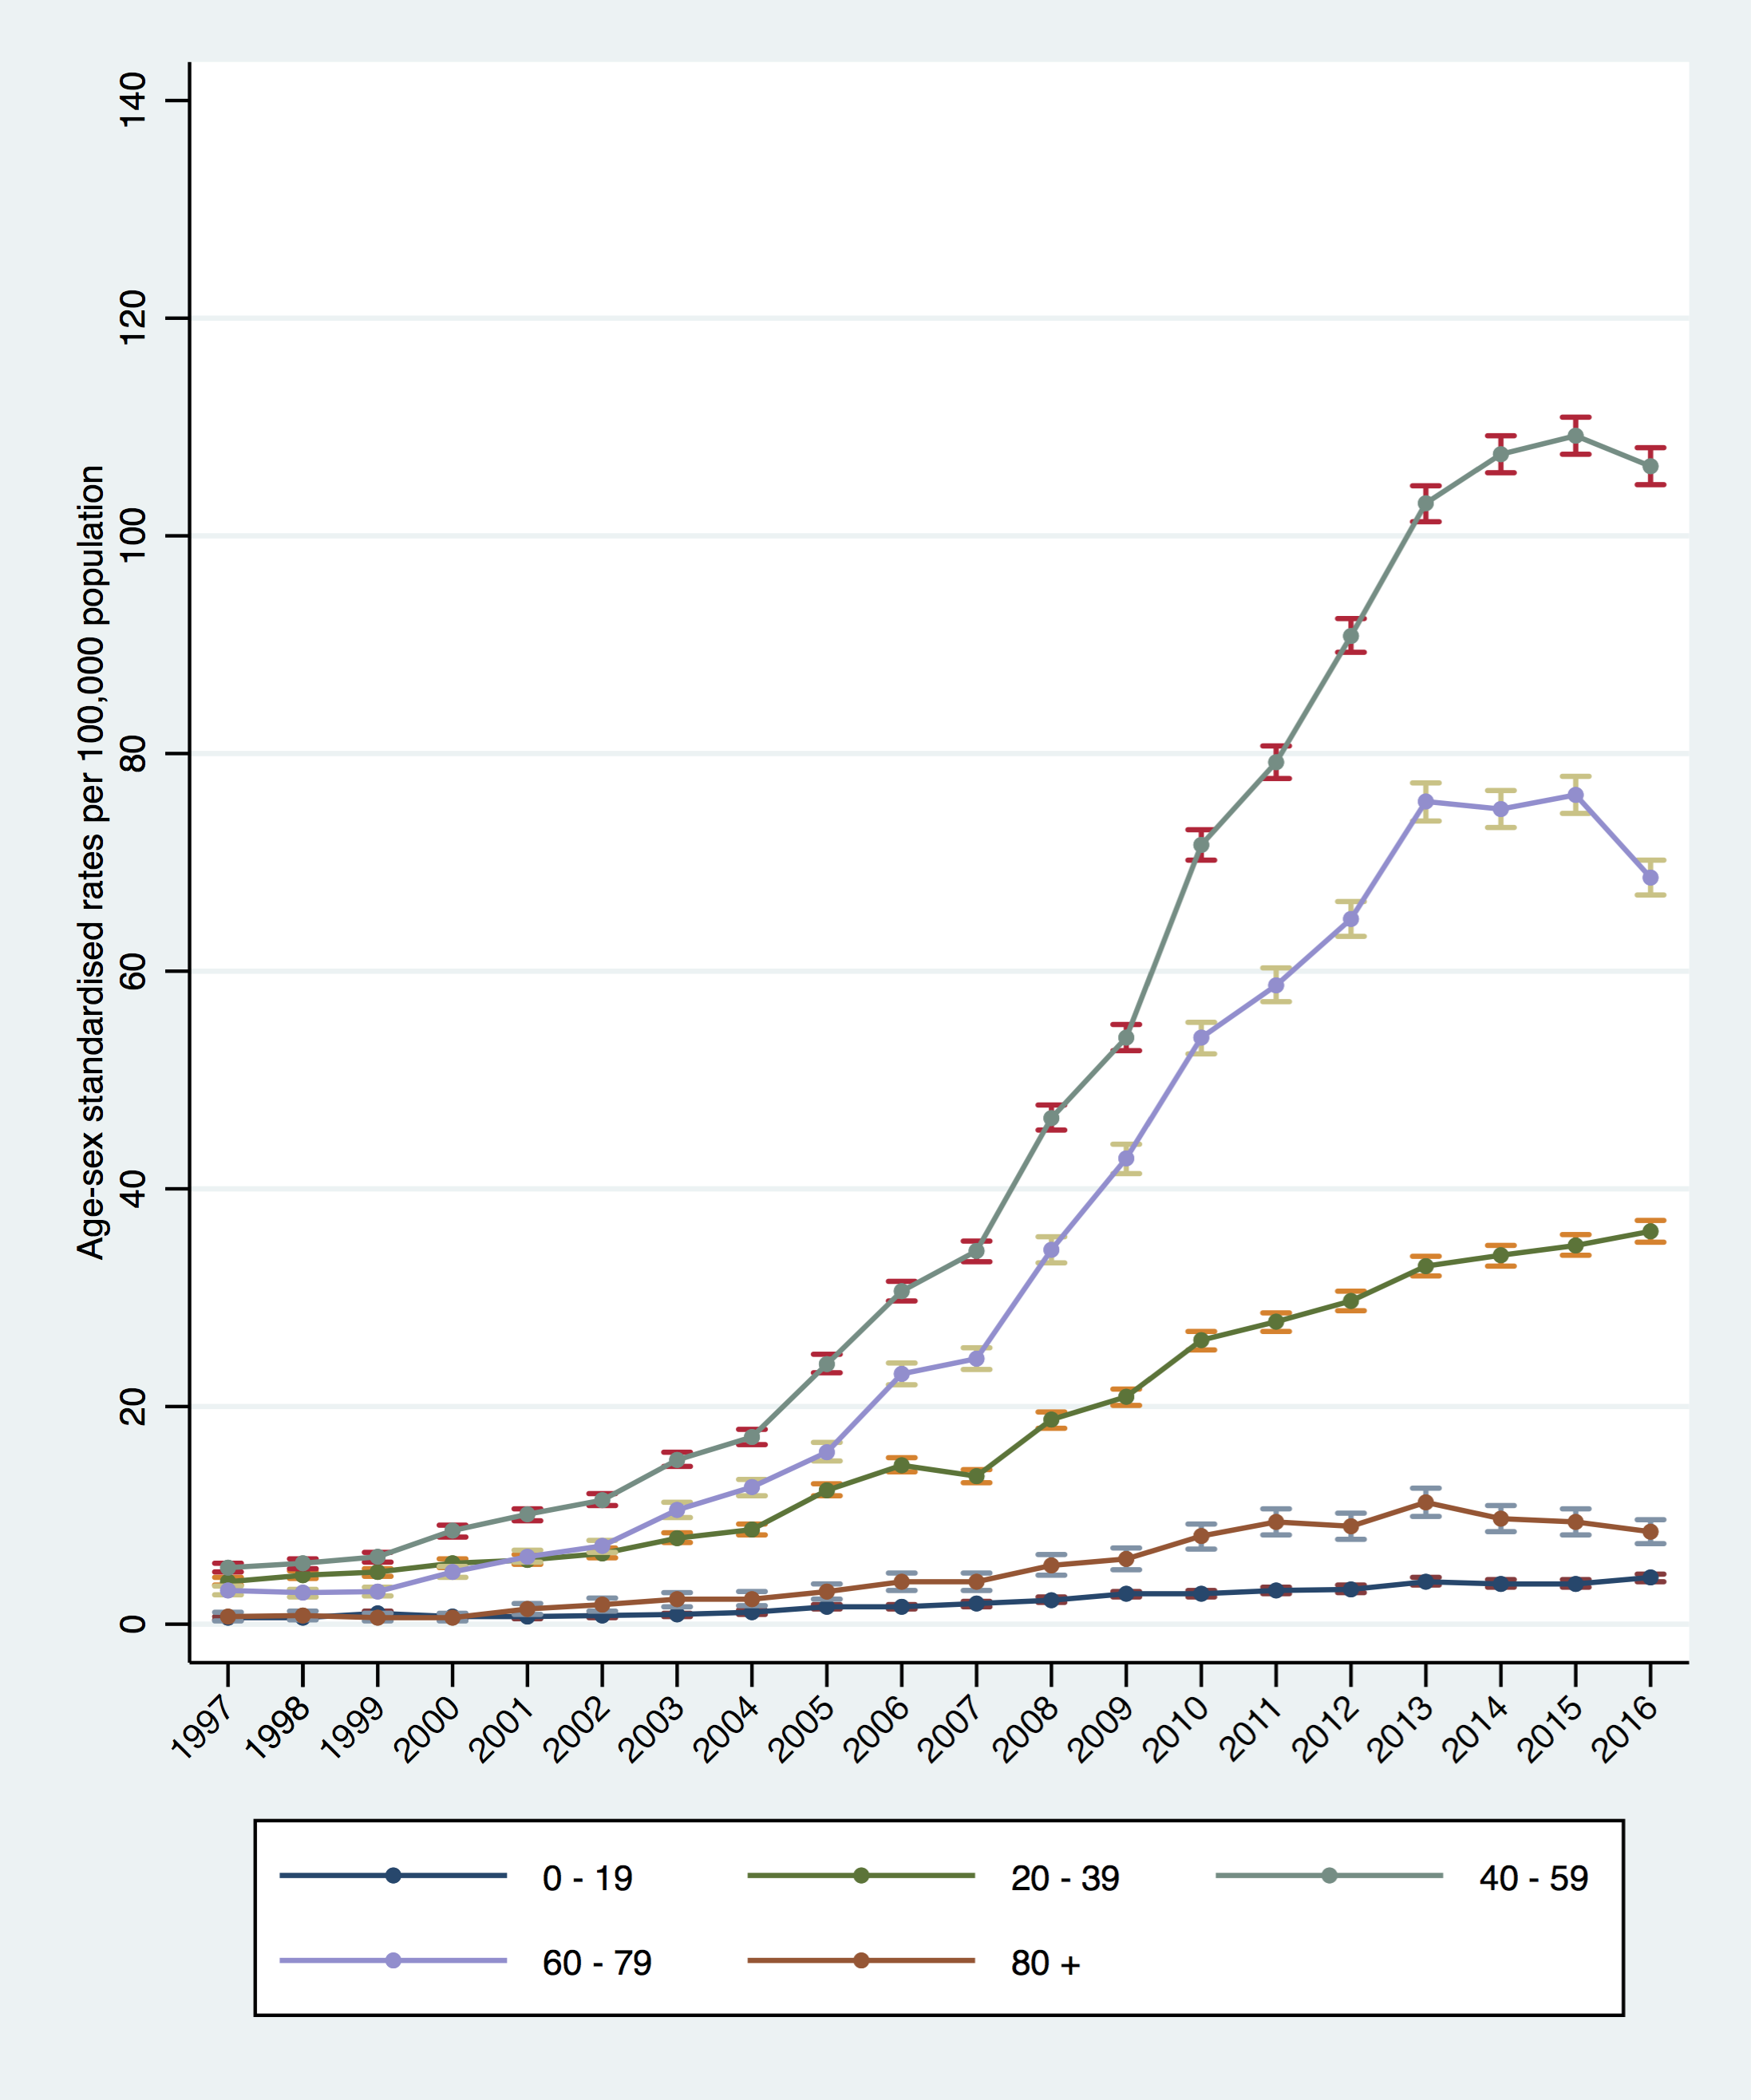

**S3:** Gender standardised rates of diagnostic arthroscopy per 100,000 population by age group and year



**S4:** Plot summarising the variation in the rate of washout / lavage /100,000 population by CCG in 2016-17

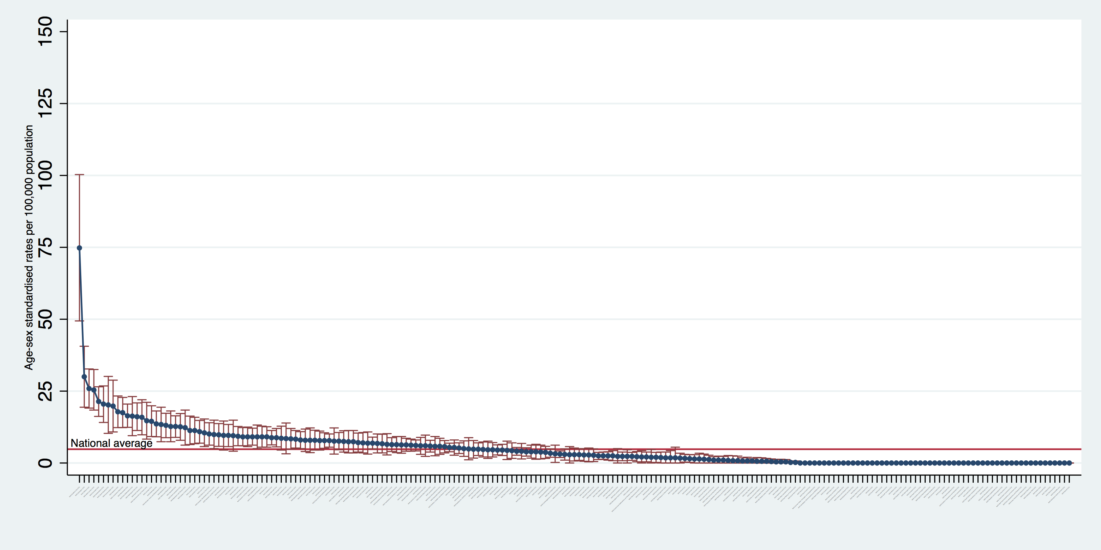

**S5:** Plot summarising the variation in the rate of chondroplasty /100,000 population by CCG in 2016-17

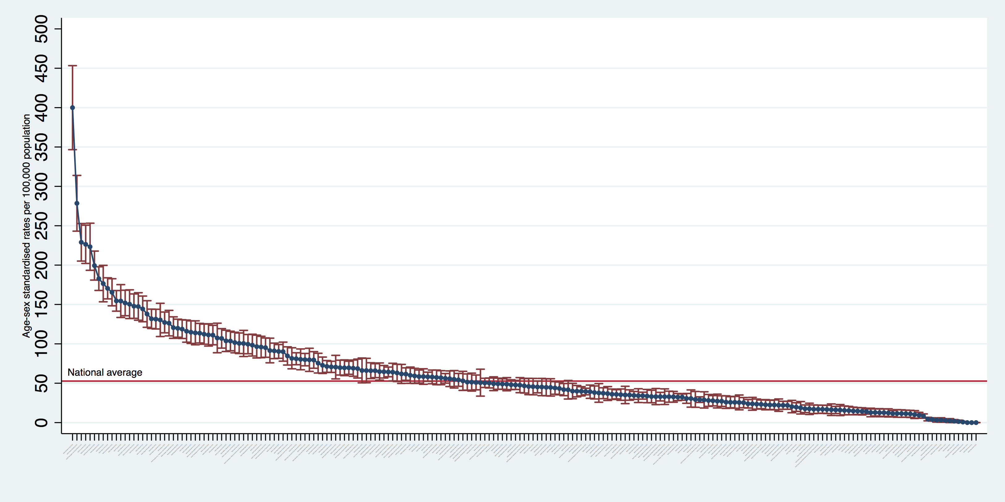

**S6:** Plot summarising the variation in the rate of diagnostic arthroscopy /100,000 population by CCG in 2016-17

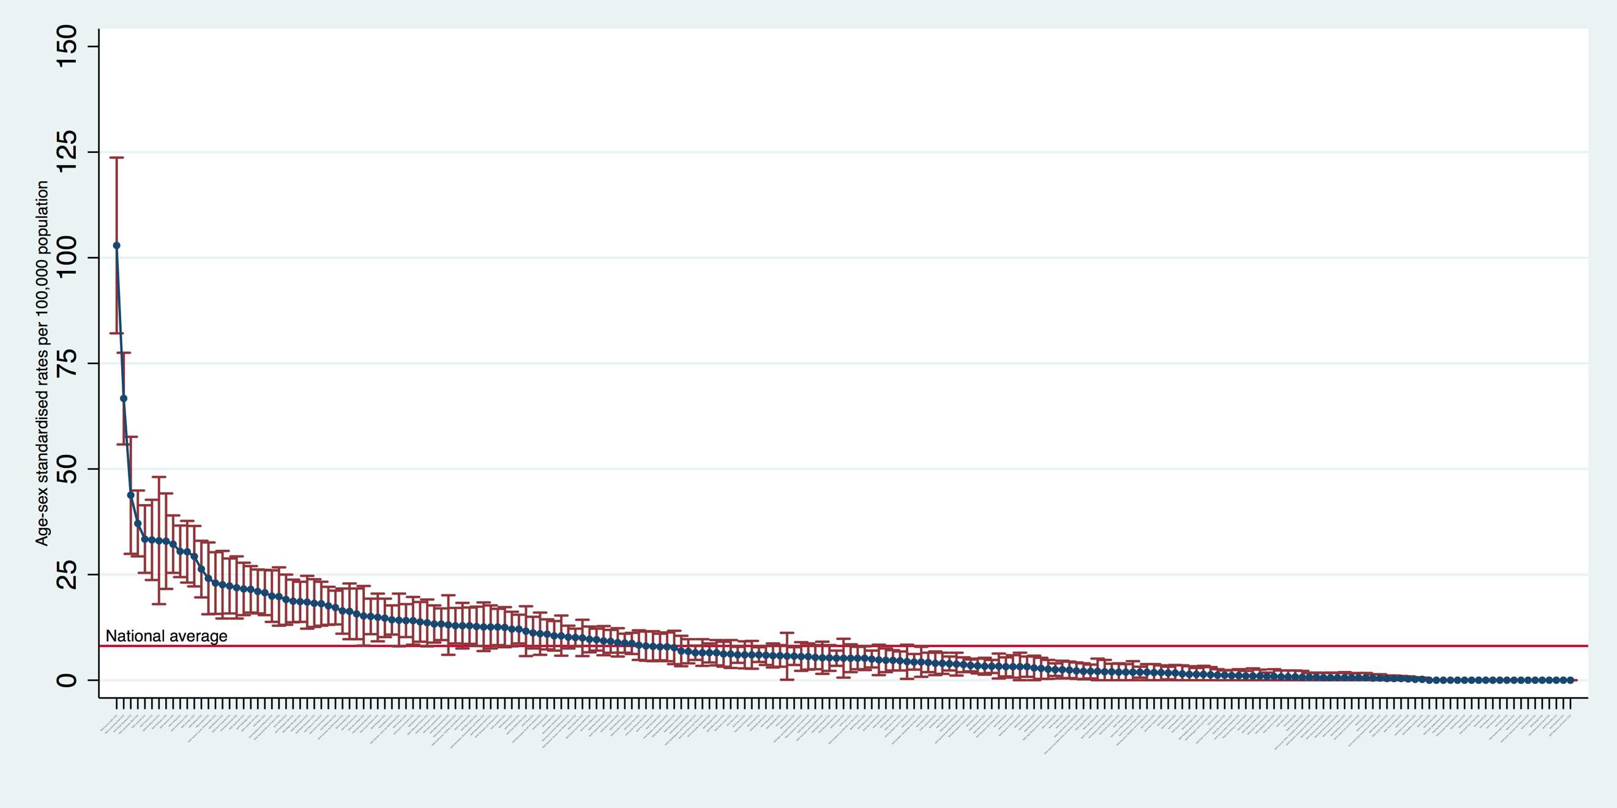

**Supplementary Table 1:** Variability in the rate of change in APM per 100,000 population by year by CCG

|  |  |  |  |  |  |  |  |
| --- | --- | --- | --- | --- | --- | --- | --- |
| **Years** | **National average** | **Variability in rate of change (number of CCGs)** | | | | | |
| **Increase > 5%** | | **+/- 5%** | | **Decrease > 5%** | |
| **N** | **%** | **N** | **%** | **N** | **%** |
| 2002-03 to 2003-04 | 6.3 | 118 | 57% | 30 | 14% | 59 | 29% |
| 2003-04 to 2004-05 | 5.1 | 109 | 53% | 29 | 14% | 69 | 33% |
| 2004-05 to 2005-06 | 2.2 | 100 | 48% | 30 | 14% | 77 | 37% |
| 2005-06 to 2006-07 | 7.2 | 111 | 54% | 29 | 14% | 67 | 32% |
| 2006-07 to 2007-08 | 21.1 | 153 | 74% | 21 | 10% | 33 | 16% |
| 2007-08 to 2008-09 | 12.8 | 129 | 62% | 31 | 15% | 47 | 23% |
| 2008-09 to 2009-10 | 7.4 | 124 | 60% | 25 | 12% | 58 | 28% |
| 2009-10 to 2010-11 | 14.6 | 137 | 66% | 33 | 16% | 37 | 18% |
| 2010-11 to 2011-12 | -0.9 | 77 | 37% | 46 | 22% | 84 | 41% |
| 2011-12 to 2012-13 | - 1.5 | 79 | 38% | 44 | 21% | 84 | 41% |
| 2012-13 to 2013-14 | 3.2 | 94 | 45% | 50 | 24% | 63 | 30% |
| 2013-14 to 2014-15 | - 4.6 | 71 | 34% | 54 | 26% | 82 | 40% |
| 2014-15 to 2015-16 | - 10.1 | 59 | 29% | 37 | 18% | 111 | 54% |
| 2015-16 to 2016-17 | - 14.2 | 52 | 25% | 35 | 17% | 120 | 58% |