Poppelaars et al. Appendix 2.

Survival plots of patients at relevant levels of factors in the regression model.

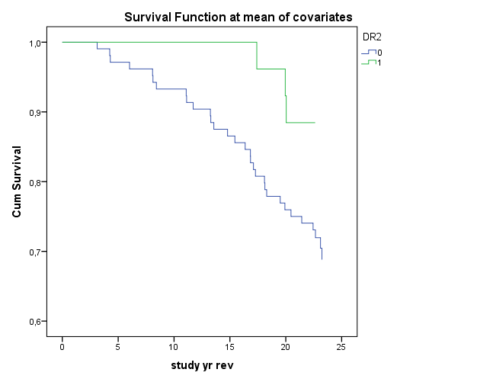

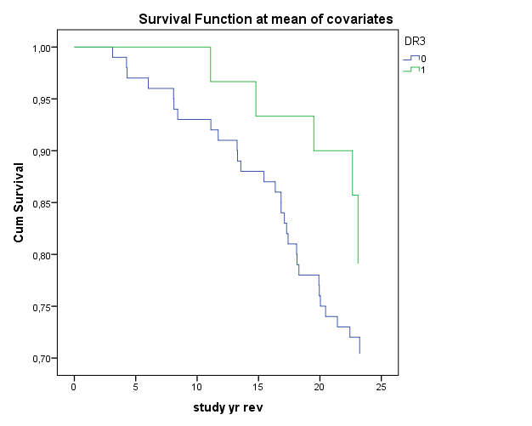

∆S28: change of joint damage score at week 28.

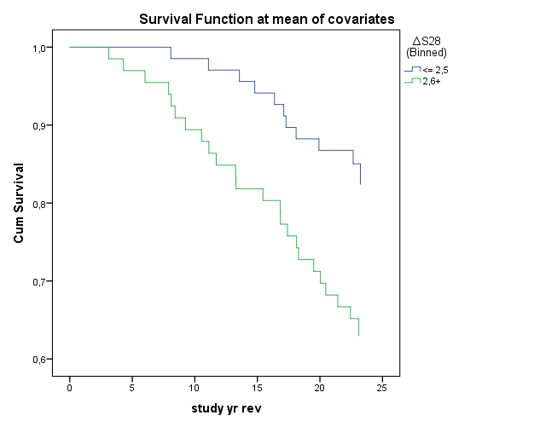

HAQ: Health Assessment Questionnaire (functional disability scale).

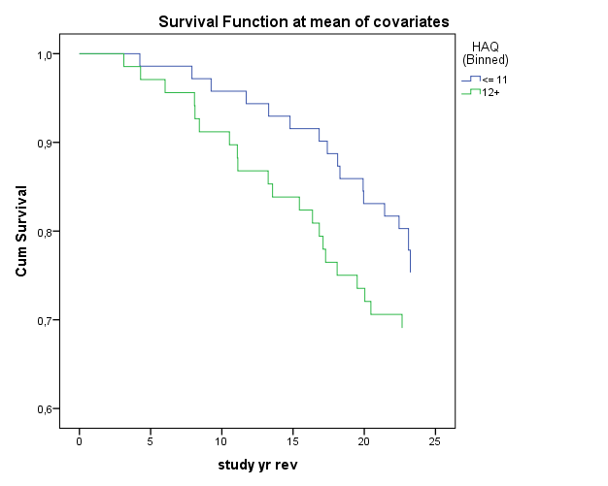

r st kl: disease duration from start of symptoms.

