**SUPPLEMENTARY RESULTS**

**Individual Adverse Events**

In terms of individual adverse events, rates of constipation were provided by 16 of the eligible trials, reported in 15 articles. [17, 18, 19, 20, 33, 34, 36, 37, 38, 39, 40, 41, 42, 43, 46] All drugs, with the exception of rifaximin 550mg t.i.d., were associated with an increased risk of constipation and, when ranked using a P-score, rifaximin 550mg t.i.d. was the best, and alosetron 0.5mg b.i.d. the worst (P-scores 0.99 and 0.06 respectively). Indirect comparison of active treatments revealed that both placebo and rifaximin 550mg t.i.d. were significantly less likely to cause constipation than all other individual drugs, and dosages, but there were no other differences. There were no significant differences between any of the active therapies and placebo, in terms of incidence of either nausea or headache. Nine RCTs, reported in seven articles, provided information concerning abdominal pain. [17, 20, 36, 37, 38, 39, 43] Eluxadoline 100mg b.i.d. and alosetron 1mg b.i.d. were more likely than placebo to cause abdominal pain, with rifaximin 550mg t.i.d. the best, and alosetron 1mg b.i.d. the worst (P scores 0.89 and 0.18 respectively). Indirect comparison of active treatments revealed that both placebo and rifaximin 550mg t.i.d. were significantly less likely to cause abdominal pain than either eluxadoline 100mg b.i.d. or alosetron 1mg b.i.d.

**SUPPLEMENTARY TABLES**

**Supplementary Table 1. Eligibility Criteria.**

|  |
| --- |
| Randomised controlled trials |
| Adults (participants aged >18 years) |
| Diagnosis of IBS-D or IBS-M based on either a clinician’s opinion, or meeting specific diagnostic criteria*, supplemented by negative investigations where trials deemed this necessary. |
| Compared alosetron, eluxadoline, ramosetron, or rifaximin with each other, or with placebo. |
| Minimum follow-up duration of 12 weeks. |
| Dichotomous assessment of response to therapy at 12 weeks†. |

*Manning, Kruis score, Rome I, II, III, or IV.

†Preferably patient-reported, and according to the FDA-recommended endpoint for treatment trials in IBS, but if this was not available then as assessed by a physician or questionnaire data.

**Supplementary Table 2. Risk of Bias of Randomised Controlled Trials of Pharmacological Therapies Versus Placebo in IBS-D or IBS-M.**

|  |  |  |  |  |  |  |
| --- | --- | --- | --- | --- | --- | --- |
| **Study, drug, and dose** | **Stated Method of Generation of Randomisation Schedule** | **Stated Method of Concealment of Treatment Allocation** | **Blinding** | **No Evidence of Incomplete Outcomes Data** | **No Evidence of Selective Reporting of Outcomes** | **Low Risk of Bias** |
| **Camilleri 1999 [34], alosetron 1mg b.i.d.** | No | No | Double | No | Yes | No |
| **Camilleri 2000 [18], alosetron 1mg b.i.d.** | Yes | Yes | Double | Yes | Yes | Yes |
| **Camilleri 2001 [33], alosetron 1mg b.i.d.** | Yes | No | Double | Yes | Yes | No |
| **Lembo 2001 [37], alosetron 1mg b.i.d.** | No | No | Double | No | Yes | No |
| **Chey 2004 [35], alosetron 1mg b.i.d.** | No | No | Double | Yes | Yes | No |
| **Chang 2005 [36], alosetron 0.5mg or 1mg b.i.d.** | Yes | No | Double | Yes | Yes | No |
| **Krause 2007 [38], alosetron 1mg b.i.d.** | Yes | Yes | Double | Yes | Yes | Yes |
| **Matsueda 2008a [40], ramosetron 5mcg o.d.** | No | Yes | Double | Yes | Yes | No |
| **Matsueda 2008b NCT00189696 [39]** | No | No | Double | Yes | Yes | No |
| **Fukudo 2014 NCT01225237 [41]** | Yes | Yes | Double | Yes | Yes | Yes |
| **Fukudo 2016 NCT01870895 [19]** | Yes | Yes | Double | Yes | Yes | Yes |
| **Fukudo 2017 NCT01274000 [42]** | Yes | Yes | Double | Yes | Yes | Yes |
| **Pimentel 2011a**  **(Target 1) NCT00731679 [17]** | Yes | Yes | Double | Yes | Yes | Yes |
| **Pimentel 2011b**  **(Target 2) NCT00724126 [17]** | Yes | Yes | Double | Yes | Yes | Yes |
| **Dove 2013 NCT01130272 [43]** | Yes | Yes | Double | Yes | Yes | Yes |
| **Lembo 2016a**  **(IBS-3001) NCT01553591 [20]** | Yes | Yes | Double | Yes | Yes | Yes |
| **Lembo 2016b**  **(IBS-3002) NCT01553747 [20]** | Yes | Yes | Double | Yes | Yes | Yes |
| **Brenner 2018 (RELIEF) NCT02959983 [46]** | No | No | Double | Yes | Yes | No |

Boxes shaded green denote that the risk of bias item was reported, while those shaded red denote it was not reported.

**Supplementary Table 3. League Table for Failure to Achieve an Abdominal Pain Response.**

|  |  |  |  |  |  |  |  |
| --- | --- | --- | --- | --- | --- | --- | --- |
| **Ramosetron 2.5mcg o.d.** |  |  |  |  |  |  |  |
| 0.91 (0.78; 1.07) | **Ramosetron 5mcg o.d.** |  |  |  |  |  |  |
| 0.90 (0.78; 1.04) | 0.99 (0.89; 1.10) | **Alosetron 1mg b.i.d.** |  |  |  |  |  |
| 0.88 (0.68; 1.13) | 0.96 (0.76; 1.21) | 0.97 (0.77; 1.22) | **Alosetron 0.5mg b.i.d.** |  |  |  |  |
| 0.84 (0.72; 0.97) | 0.91 (0.82; 1.02) | 0.93 (0.84; 1.02) | 0.95 (0.76; 1.20) | **Eluxadoline 100mg b.i.d.** |  |
| 0.79 (0.68; 0.91) | 0.86 (0.77; 0.96) | 0.87 (0.80; 0.95) | 0.90 (0.71; 1.13) | 0.94 (0.86; 1.03) | **Rifaximin 550mg t.i.d.** |
| 0.78 (0.67; 0.92) | 0.86 (0.76; 0.97) | 0.87 (0.78; 0.96) | 0.89 (0.70; 1.13) | 0.94 (0.84; 1.05) | 1.00 (0.90; 1.11) | **Eluxadoline 75mg b.i.d.** |  |
| 0.75 (0.65; 0.85) | 0.82 (0.75; 0.89) | 0.83 (0.78; 0.88) | 0.85 (0.68; 1.06) | 0.89 (0.83; 0.96) | 0.95 (0.89; 1.01) | 0.95 (0.88; 1.04) | **Placebo** |

Relative risk with 95% confidence intervals in parentheses. Comparisons, column versus row, should be read from left to right, and are ordered relative to their overall efficacy. The treatment in the top left position is ranked as best after the network meta-analysis of indirect effects.

Boxes shaded green denote a statistically significant difference.

**Supplementary Table 4. League Table for Failure to Achieve a Stool Consistency Response.**

|  |  |  |  |  |  |  |  |
| --- | --- | --- | --- | --- | --- | --- | --- |
| **Alosetron 1mg b.i.d.** |  |  |  |  |  |  |  |
| 0.90 (0.76; 1.07) | **Ramosetron 5mcg o.d.** |  |  |  |  |  |  |
| 0.90 (0.73; 1.10) | 1.00 (0.85; 1.18) | **Rifaximin 550mg t.i.d.** |  |  |  |  |  |
| 0.90 (0.74; 1.08) | 0.99 (0.86; 1.15) | 1.00 (0.83; 1.20) | **Ramosetron 2.5mcg o.d.** |  |  |  |  |
| 0.82 (0.69; 0.97) | 0.91 (0.81; 1.02) | 0.91 (0.78; 1.07) | 0.92 (0.80; 1.05) | **Eluxadoline 75mg b.i.d.** |  |
| 0.81 (0.69; 0.96) | 0.90 (0.81; 1.00) | 0.91 (0.78; 1.05) | 0.91 (0.80; 1.03) | 0.99 (0.90; 1.09) | **Eluxadoline 100mg b.i.d.** |
| 0.70 (0.60; 0.81) | 0.78 (0.71; 0.85) | 0.78 (0.68; 0.89) | 0.78 (0.69; 0.88) | 0.85 (0.79; 0.92) | 0.86 (0.81; 0.91) | **Placebo** |  |

Relative risk with 95% confidence intervals in parentheses. Comparisons, column versus row, should be read from left to right, and are ordered relative to their overall efficacy. The treatment in the top left position is ranked as best after the network meta-analysis of indirect effects.

Boxes shaded green denote a statistically significant difference.

**SUPPLEMENTARY FIGURES**

**Supplementary Figure 1. Flow Diagram of Assessment of Studies Identified in the Systematic Review.**

Studies identified in literature search (n = 1879)

Excluded (title and abstract revealed not appropriate) (n = 1821)

Studies retrieved for evaluation (n = 58)

Excluded (n = 40) because:

* Dual publication = 26
* Follow-up duration less than 12 weeks = 9
* Mixed population of patients with IBS, no data for non-constipated IBS patients available = 2
* Pooled analysis of adverse events data = 1
* Retreatment trial following open label treatment with active drug = 1
* Review article = 1

Eligible articles (n = 18) reporting:

* 7 trials of alosetron
* 5 trials of ramosetron
* 2 trials of rifaximin
* 4 trials of eluxadoline

**Supplementary Figure 2. Network Plot for Failure to Achieve the FDA-recommended Endpoint to Define Treatment Response.**

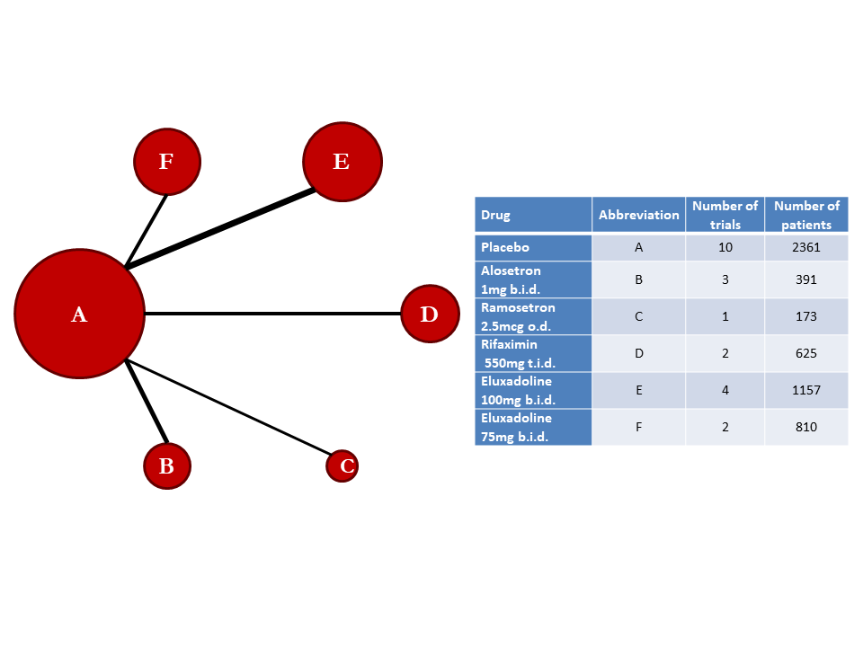

**Supplementary Figure 3. Funnel Plot for Failure to Achieve the FDA-recommended Endpoint to Define Treatment Response.**

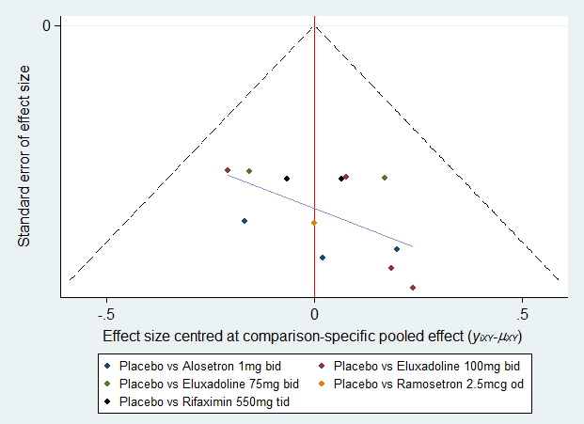

Note:The horizontal axis represents the difference between the comparison-specific and study-specific effect sizes.

**Supplementary Figure 4. Funnel Plot for Failure to Achieve a Global IBS Symptom Response.**

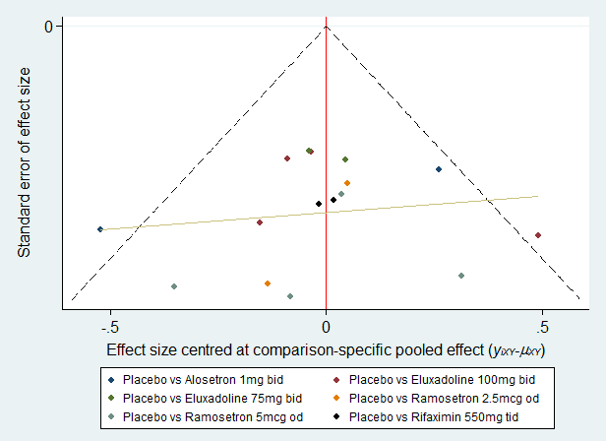

Note:The horizontal axis represents the difference between the comparison-specific and study-specific effect sizes.

**Supplementary Figure 5. Funnel Plot for Failure to Achieve an Abdominal Pain Response.**

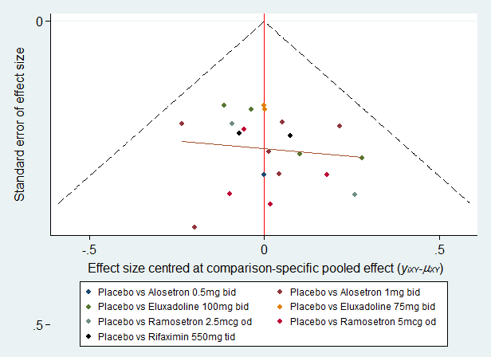

Note:The horizontal axis represents the difference between the comparison-specific and study-specific effect sizes.

**Supplementary Figure 6. Funnel Plot for Failure to Achieve a Stool Consistency Response.**

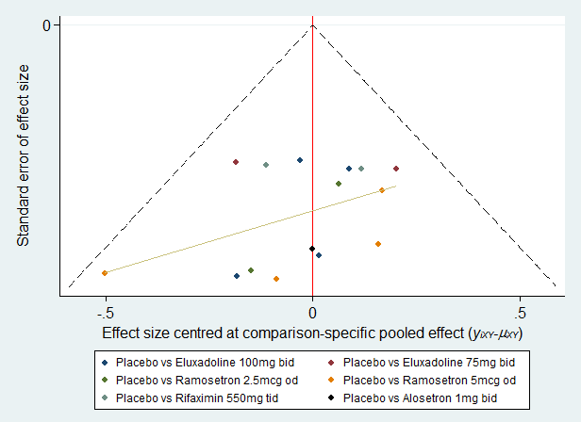

Note:The horizontal axis represents the difference between the comparison-specific and study-specific effect sizes.

**Supplementary Figure 7. Funnel Plot for Overall Adverse Events.**

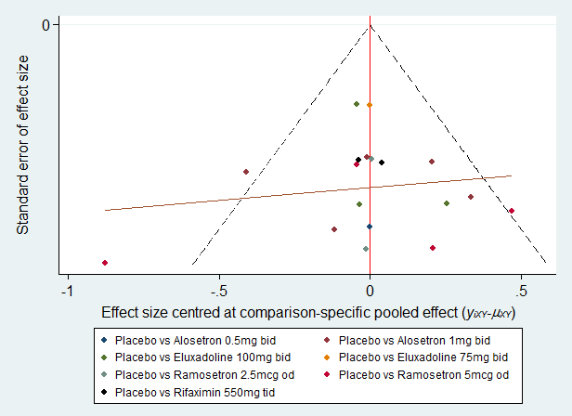

Note:The horizontal axis represents the difference between the comparison-specific and study-specific effect sizes.

**Supplementary Figure 8. Forest Plot of the Indirect Evidence for Overall Adverse Events.**

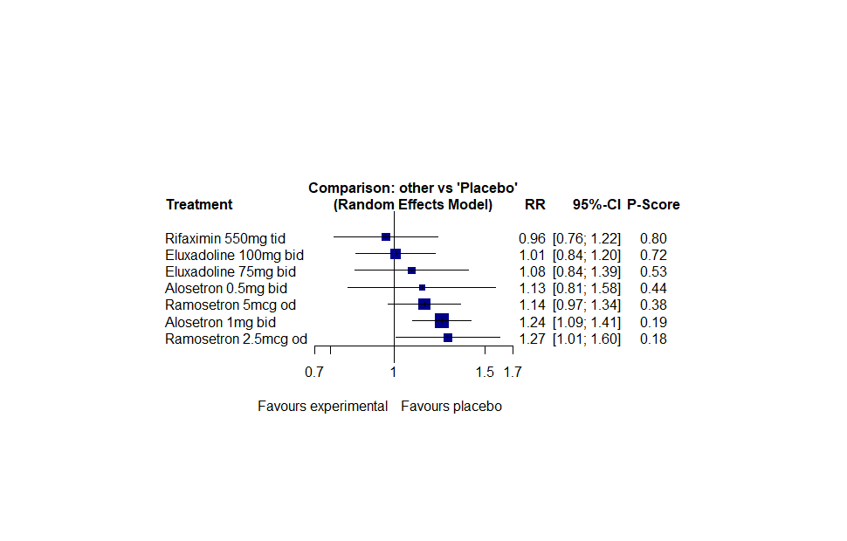

Note: The P-score is the probability of each treatment being ranked as best in the network analysis. A higher score equates to a greater probability of being ranked first.